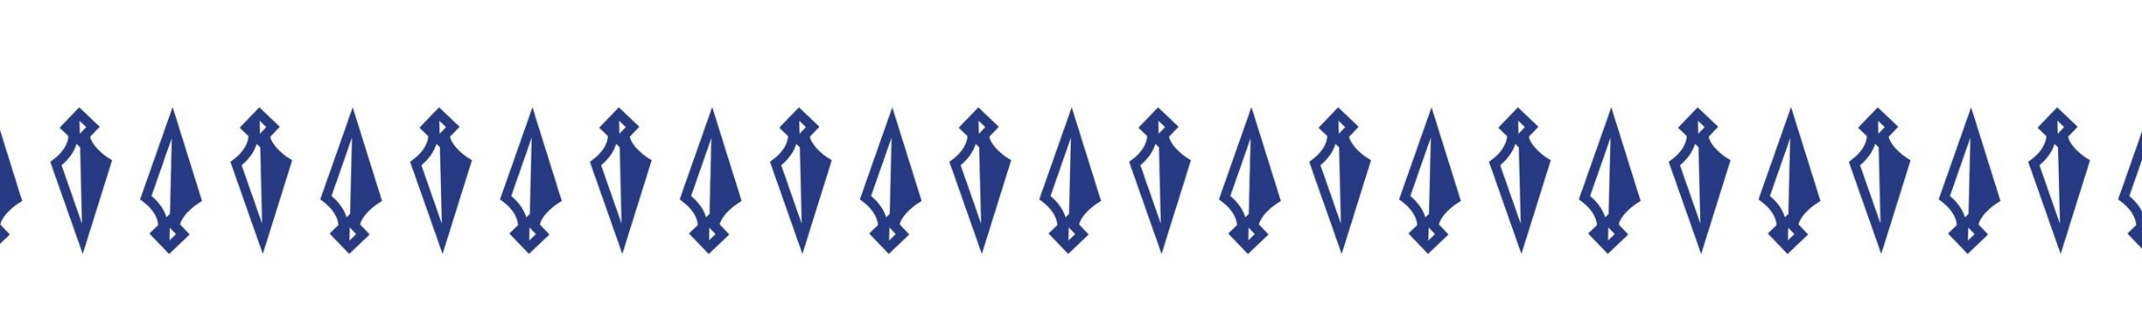
State Champion Corner
-Maine State Champion Guardians as archived from 2002 to present-

Casey Trafton, Javelin (117’), 2002

Liz Trafton, Javelin (112’4), 2004

Josh Pritchett, Discus (138’5), 2004

Liz Trafton, Javelin (113’), 2005

Liz Trafton, Javelin (113’7”), 2006

Liz Trafton, Discus (107’4”), 2006

Liz Trafton, Shot Put (36’5.5”), 2007

Amberle Bennett, Javelin (101’7”), 2010

Amberle Bennett, Javelin (106’7”), 2011

Ruth Towne, Discus (107’4”), 2012

Laken Kerrigan, 3200m (11:52), 2013

Kylene desmith, triple jump (35’3.5”), 2014

Laken Kerrigan, 1600m (5:20.88), 2014

Isaac la croix, 800m, (2:01.96), 2014

Kylene Desmith, 100HH (15.8), 2015

Kylene desmith, triple jump (37’1.25”), 2015

Ellie Leech, Javelin (99’10”), 2021

Ellie Leech, Javelin (114’8”), 2023

